Name: Chidinma Idonor, Joseph Mensah, Jula Sherene Mervin
Course: Optical Network Lab 1
Date: September 8, 2025
Instructor: Dr LoPresti Peter

Characterization of Optical Fiber
1. Objective/ Introduction
The objective of this lab is to study the fundamental properties of optical fibers, with a focus on attenuation and dispersion at different wavelengths. The experiment involves characterizing a sample fiber using a power meter and an Optical Time-Domain Reflectometer (OTDR). These measurements will provide insights into the fiber’s characteristics and its behavior under varying wavelengths. This lab serves as a foundational step in understanding optical fiber losses, where minimizing signal attenuation and ensuring optimal signal clarity are critical.
2. Equipment Used
- Light Source
- Power Meter
- OTDR
- Fiber and Connectors
3.1 Loss Measurement with a Power Meter
At Wavelength of 1310nm
- We powered the light source and the meter and both were set to a wavelength of 1310 nm
- The source was connected using an optical patch cord to the power meter, and the input was measured as 15.50dBm while the output was measured as -27.50dBm.
- We calculated the power lost in dB by subtracting the output power from the input power. Which is 15.50-(-27.50) = 43dBm
- Also, we calculated for the effective absorption coefficient (α) in dB/km by dividing the power loss (43dBm) by the total length of the fiber (40.046km) and got α =
In summary:
Total length =
Input power =
Output power =
Power loss =
Absorption Coefficient, α =

At Wavelength of 1550nm
- We powered the light source and the meter and both were set to a wavelength of 1550nm
- The source was connected using an optical patch cord to the power meter, and the input was measured as 15.50dBm while the output was measured as -20.80dBm.
- We calculated the power lost in dB by subtracting the output power from the input power. Which is 15.50-(-20.80) = 36.3dBm
- Also, we calculated for the effective absorption coefficient (α) in dB/km by dividing the power loss (43dBm) by the total length of the fiber (40.046km), and got α =
In summary:
    - Total length =
    - Input power =
- Output power =
- Power loss =
- Absorption Coefficient, α =

3.2 Fiber Characterization using OTDR
At Wavelength of 1310 nm

Instrument set up:

• Power on OTDR =
• Identify fiber type Single Mode Fiber (SMF-28) and total length =
• Input refractive index (IOR) for SMF-28 at 1550 nm.
• Configure instrument parameters:
- Units: km
- Resolution = smallest possible
- Range: ≥ 10% longer than fiber length
- Averaging mode: medium =
- Pulse width = 50 ns/5.0 m
- Wavelengths = 1310 nm (single-mode only)
- Loss mode: 2-point loss

At Wavelength of 1550 nm
- Units: km
- Resolution = smallest possible
- Range: ≥ 10% longer than fiber length
- Averaging mode: medium =
- Pulse width = 50 ns/5.0 m
- Wavelengths = 1550 nm (single-mode only)
- Loss mode: 2-point loss

3.3 Comparison of OTDR and Power Meter Measurements
a. For measuring the total power loss on a test fiber, the power meter loss measurements
are typically more accurate than OTDR loss measurements. Calculate the percent
difference between you power meter loss and OTDR loss. Include this calculation in
your lab report
Solution
At the 1550 nm wavelength, the percent difference between the power meter loss and the OTDR loss was 2.92%, with the power meter measuring a total loss of 7.75 dBm and the OTDR recording 7.98 dBm. However, at the 1310 nm wavelength, ……….

b. How well did the values compare with the specified values for the fiber? What
sources of loss might be included in your power meter measurements that are not
included in the specification sheet values?
Solution

c. Assuming the power meter is more accurate, why would you use the OTDR?
Solution

d. On the OTDR, you should have observed a very fast drop in the power over the first
few tens of meters before the more gradual slope starts. This seems to indicate that
there is a lot of reflection at the beginning of the fiber, and then a lot of power is lost by the fiber. Using knowledge of the basic concepts from Chapter 2, give an
explanation for this.
Solution

3.4 Fiber Chromatic Dispersion Calculation
a. Locate the formula for chromatic dispersion on the attached spec sheet.
Solution
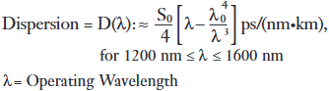

b. Calculate the value of D at a wavelength of 1550nm (D(1550)). Assume the maximum value for S0 and that λ0 = 1312 nm
Solution
Given:
- Dispersion parameter, D(λ) = [ps/(nm·km)]
- Zero-dispersion slope, So = [ps/(nm²·km)]
- Zero-dispersion wavelength [nm] = λ0\lambda_0λ0​
- Operating wavelength [nm] = λ\lambdaλ

Given values:

λ0=1312 nm
- λ=1550 nm
- S0​≈0.092ps/(nm2⋅km)

λ3λ04​​

c. Multiply D(1550) times the measured length of your fiber sample. What does this
value represent?

d. Using Microsoft Excel or another graphing program, create a graph of D(λ) from
1300nm to 1600nm. Assume the maximum value for S0 and that λ0 = 1312 nm.
Solution

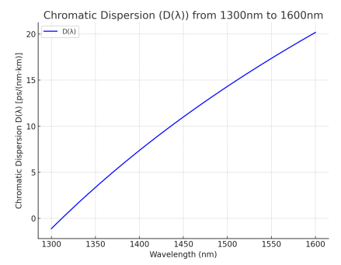
The graph shows …..

Fig

e. if you used an LED with a bandwidth of 30nm and a center wavelength of
1550nm, what would be the expected delay/spread of a pulse for the measured
fiber length?
Solution
Using the formular
t = ∆λ ∗ D(λ) ∗ L =⇒ 30 ∗ 40.054 ∗ 17.349 = 20.85ns
Therefore, the delay would be 20.85 ns

4 Conclusion

